1. What are escape characters, and how do you use them?

**Answer:**

An escape character is a backslash(\) followed by the character you want to insert.

The below is the example to show how to use escape character:

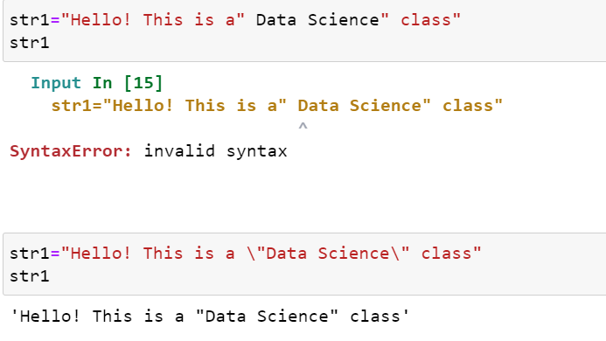

There are several other escape characters :

\’ – Single quote

\\ - Backslash

\n – New line

\t – Tab

\b – Backspace

2. What do the escape characters n and t stand for?

**Answer:**

\n stands for new line

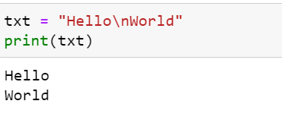

\t stands for tab

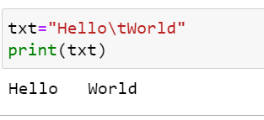

3. What is the way to include backslash characters in a string?

**Answer:**

The \\ escape character will represent a backslash character.

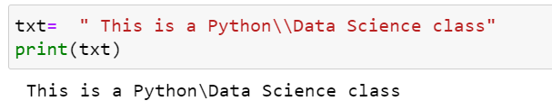

4. The string “Howl’s Moving Castle” is a correct value. Why isn’t the single quote character in the

word Howl’s not escaped a problem?

**Answer:**

The single quote in Howl’s is not a problem because we’ve used double quotes (“”) to mark the string.

5. How do you write a string of newlines if you don’t want to use the n character?

**Answer:**

We can use multiline strings by using triple quotes(“”” “””).

6. What are the values of the given expressions?

‘Hello, world!’[1] => ‘e’

‘Hello, world!’[0:5] => ‘Hello’

‘Hello, world!’[:5] => ‘Hello’

‘Hello, world!’[3:] => ‘lo, world!’

**Answer:**

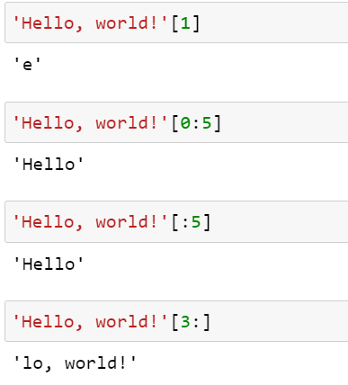

7. What are the values of the following expressions?

‘Hello’.upper() => HELLO

‘Hello’.upper().isupper() => True

‘Hello’.upper().lower() => hello

**Answer:**

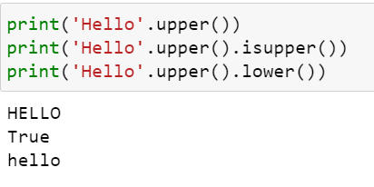

8. What are the values of the following expressions?

‘Remember, remember, the fifth of July.’.split()

* [‘Remember’, ‘remember’, ‘the’, ‘fifth’, ‘of’, ‘July.’]

‘-‘.join(‘There can only one.’.split())

* ‘There-can-only-one.’

**Answer:**

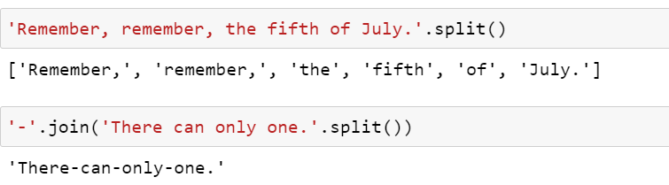

9. What are the methods for right-justifying, left-justifying, and centering a string?

**Answer:**

rjust(), ljust() and center() are the string methods respectively.

10. What is the best way to remove whitespace characters from the start or end?

**Answer:**

The lstrip() and rstrip() methods remove whitespace from the left and right ends of a string, respectively.